

Mental Health Symptoms
Emotional Symptoms
-Moodiness
-Irritability or short temper
-Agitation/inability to relax
-Feeling overwhelmed
-Sense of loneliness
-Depression/general unhappiness

Cognitive Symptoms
-Inability to concentrate
-Memory problems
-Poor judgement
-Anxious/racing thoughts
-Constant worrying
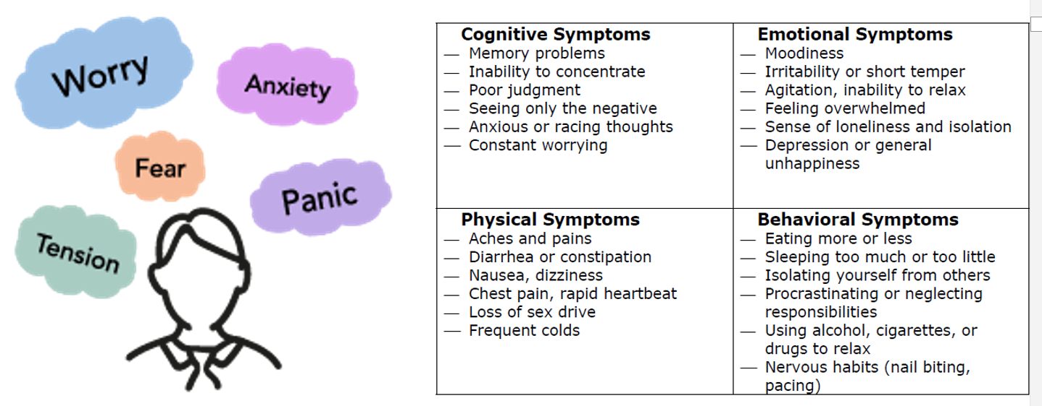

Physical Symptoms
-Aches and pains with no medical cause
-Constipation and/or diarrhea
-Nausea, dizziness
-Chest pains/rapid heart beat
-Weakened immune system/frequent colds
Behavioral Symptoms
-Eating more or less
-Sleeping too much or too little
-Isolating yourself from others
-Procrastinating or neglecting responsibilities
-Using alcohol, cigarettes or drugs to relax

Reflection Questions
- Are there any distractions in your life that take you from your calling or purpose? When you acknowledge and recognize that you are off track, what thoughts and emotions do you experience?
- Do you have any vices or strongholds that you struggle to overcome? How does your thinking, mood, and behavior change when you're unable to engage with these vices, (ex. hobbies, people, success, or power?
- How important is your reputation and other’s opinion of you? When their views don’t match your expectations, what thoughts and feelings arise in you?

Ways to Improve Your Mental Health
- Pray – tell God exactly how you feel about what you are dealing with. Be transparently honest.
- Mindfulness meditation – sit quietly and listen to something encouraging or uplifting. Do some deep breathing exercises. Read something empowering.
- Healthy distractions - Listen to music. Create an uplifting playlist. Dance
- Journal – Put your thoughts and feelings on paper. Write a gratitude list.
- Constructive Conversations – have a conversation with a supportive person (personal or professional)

